Lakshmi Durga Puppala

Information Technology Field Experience – EX30

Cumberland University

July 13th, 2025

**Progress Report for Milestone 2**

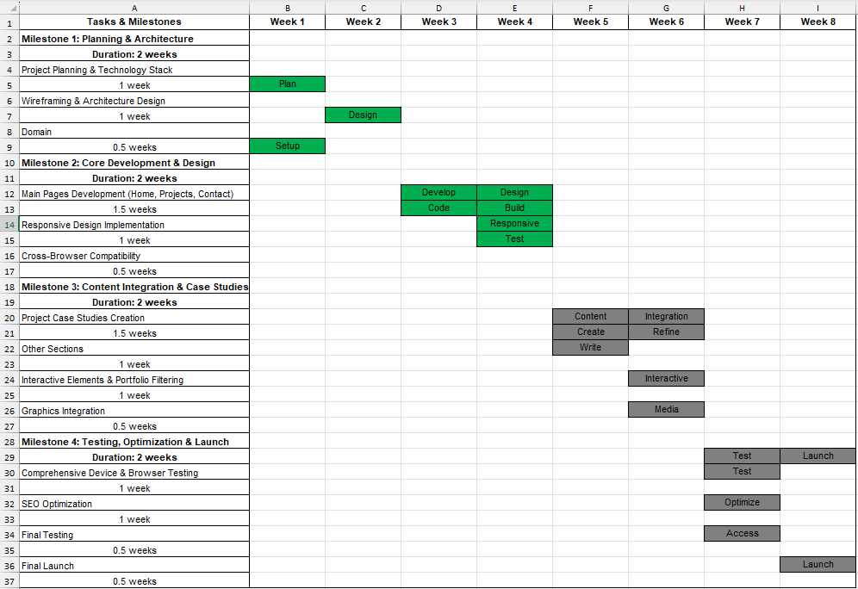**Below is the updated Gantt Chart after Milestone 2:**

|  |  |
| --- | --- |
| Completed - Finished Tasks |  |
| In Progress - Currently working |  |
| Not Started - Pending Tasks |  |

**A. What was our Milestone and subtasks?**

My second milestone was "Core Development & Design," where the goal was to build the main structure of the website. The primary subtasks for this phase included: writing the fundamental HTML and CSS code for the main pages (Home, Projects and Contact), implementing a responsive design to ensure the site looks good and functions well on all devices, from desktops to mobile phones and finally, testing for cross-browser compatibility to make sure the user experience is consistent on browsers like Chrome, Firefox and Safari.

**B. Were I successful or not? Why or why not?**

Yes, this milestone was completed successfully and on schedule. The strong foundation from the planning phase made the development process very efficient. The core pages of the website are now built, fully functional and responsive. By following the design mock-ups and plan from Milestone 1, I avoided major issues and was able to create a clean and working version of the website, which sets me up perfectly for the next stage.

**C. What did I learn from the past 2 weeks?**

During this development phase, I learned the practical importance of writing clean and well-commented code. This practice makes it much easier to manage and update the website later. I also gained hands-on experience with responsive design, learning how to use media queries effectively to adapt the layout for different screen sizes. This phase reinforced the importance of regular testing on actual devices and browsers to catch and fix issues early.

**D. What is our next Milestone, subtasks and deadline?**

My next milestone is "Content Integration & Case Studies." The focus will be on filling the website with meaningful content. The subtasks include: creating detailed project case studies to showcase my work, writing content for the other sections of the website, integrating graphics and media and implementing interactive elements for the portfolio. The deadline for completing this milestone is **July 27, 2025**.

**E. What do I need to do in our own time to make sure that I are successful?**

To ensure success in the upcoming milestone, my focus will be on content creation. I will need to dedicate time to writing clear and compelling descriptions for my project case studies and gathering all the necessary images and graphics. I will also start planning the interactive features for the portfolio to make it more engaging for users. Continuing to stick to the Gantt chart schedule and saving all progress to GitHub will be essential for staying organized and on track.